Student Record System



*A mini Project Report submitted in partial fulfillment of the requirements for the award of the degree of*

**Bachelor of Technology**

**in**

*Computer Science and Engineering*

# By

#### Om Narayan Sharma (181500839)

**Kanhaiya Bhatt (181500305)**

**Badal Bhatt (181500187)**

Under the Guidance of

Mr. Vinay Agrawal

(Assistant Professor Dept. of CEA)

Department of Computer Engineering & Applications

# Institute of Engineering & Technology

**GLA University MATHURA-281406, INDIA 2020-2021**



**Department of Computer Engineering and Applications GLA University, Mathura**

**17 km. Stone NH-2, Mathura-Delhi Road, P.O. – Chaumuha, Mathura – 281406**

## DECLARATION

We hereby declare that the work which is being presented in the Mini Project “Student Record System”, impartial fulfillment of the requirements for Mini Project viva voce, is an authentic record of our own work carried under the supervision of “Mr. Vinay Agrawal”.

Signature :

Name of Candidates: Om Narayan Sharma University Roll No. : 181500839

Signature :

Name of Candidates: Kanhaiya Bhatt University Roll No. :181500305

Signature : Name of Candidates: Badal Bhatt University Roll No.: 181500187

**Department of Computer Engineering and Applications GLA University, Mathura**

**17 km. Stone NH-2, Mathura-Delhi Road, P.O. – Chaumuha, Mathura – 281406**

#### ACKNOWLEDGEMENT

We have taken efforts in this project. However, it would not have been possible without the kind support and help of many individuals. On the completion of this project we would like to extend our sincere thanks to all of them. We are highly indebted to this project guide **Mr. Vinay Agrawal Assistant Professor of Department of Computer Engineering and Applications of GLA University** for their guidance and constant supervision as well as for providing necessary information regarding the project. We wish to extend our sincere gratitude to **Prof. Anand Singh Jalal, Head of Department of Computer Engineering and Applications and faculty of CEA Department of GLA University** for their guidance, encouragement and give this opportunity and valuable suggestion which prove extremely useful and helpful in the completion of this report. We would also like to thank all those who directly or indirectly supported or helped us in completing our project in time. We would like to express our gratitude towards our parents and member of our college for their kind cooperation and encouragement which helped me in completion of this project. All of them have willingly helped us out with their abilities.

Thanks

Om Narayan Sharma (181500839)

Kanhaiya Bhatt (181500305)

Badal Bhatt (181500187)



**Department of computer Engineering and Applications GLA University, Mathura**

**17 km. Stone NH-2, Mathura-Delhi Road, P.O. – Chaumuha, Mathura – 281406**

## ABSTRACT

A number of problems associated with student academic record management include improper course registration, late release of students' results, inaccuracy due to manual and tedious calculation and retrieval difficulties/inefficiency. In most cases the data generated by academic institutions are usually created in non-delineated files for use by different departments/units within the institutions with the same data appearing on several of these files. This means that a simple change of address would have to be processed in two and probably three or four places, depending on the number of other files on which these data appears. The development of database concept is the answer to these problems where the amount of redundant data is reduced and the possibility that data contained on a file might be inaccurate because they were never updated

|  |  |
| --- | --- |
| Declaration | i |
| Acknowledgment | ii |
| Abstract | iii |
| **1. Introduction** | 1 |
| 1.1 Motivation | 1 |
| 1.2 Overview | 1 |
| 1.3 Objective | 1 |
| 1.4 Tools Required | 2 |
| **2. Software Requirement Analysis** | 3 |
| 2.1 Problem Statement | 3 |
| 2.2 Define Modules and Functionalities | 3 |
| **3. Software Design** | 6 |
| 3.1 Data Flow Diagram | 6 |
| 3.2 Use Case Diagram | 7 |
| 3.3 E-R Diagram | 7 |
| **4. Implementation** | 8 |
| 4.1 Screenshots | 8 |
| **5. Software Testing** | 17 |
| **4. Conclusion** | 21 |
| Bibliography / References | 22 |

|  |  |
| --- | --- |
| **Fig. No.** | **Caption** |
| 3.1 | DFD |
| 3.2 | Use case Diagram |
| 3.3 | E-R Diagram |
| 4.1 | Start Panel |
| 4.2 | Login |
| 4.3 | Admin Panel |
| 4.4 | Add Student |
| 4.5 | Add Student Detail Successfully |
| 4.6 | Edit Student Details |
| 4.7 | Update Student Details Successfully |
| 4.8 | Add Course |
| 4.9 | Add Course successfully |
| 4.10 | Edit Course |
| 4.11 | Edit Course Successfully |
| 4.12 | Change Password |
| 4.13 | Change Password Successfully |
| 4.14 | Add Subject |
| 4.15 | Add Subject Successfully |
| 4.16 | Change Password |
|  |  |

## CHAPTER 1: INTRODUCTION

#### MOTIVATION

To optimize **Student Record System** is to allow the administrator of any organization to edit and find out the personal details of a student and allows the student to keep up to date his profile. It’ll also facilitate keeping all the records of student, such as their id, name, mailing address, phone number, DOB etc. So all the information about an student will be available in a few seconds. Overall, it'll make Student Record Management an easier job for the administrator and the student of any organization.

#### OVERVIEW

This project completely functions for showing it as a prototype to anyone or to showcase in college projects. Features in the project include registering the Admin, Login Features, Adding Co-admin/moderators, Adding Student, View Students of particular college which is governed by the moderator, View Students details, View Student terms marks Edit/Modify the student, Delete Student from the record.

#### OBJECTIVE

This project will serve the following objectives:-

Admin Control Structure

* + - Add Co-Admin /Moderator
    - View Moderators
    - Add College
    - Add student
    - View College Students
    - View Students Details
    - Edit Students Details
    - Delete Student
    - Login/Logout

#### TOOLS REQUIRED

Hardware Tools

* + - Processor : i3 Processor Based Computer or Higher
    - Memory : 2 GB RAM(Minimum)
    - Hard Drive: 5 GB(Minimum) Software Tools
    - Technology: HTML, CSS, JavaScript, PHP, MySQL.
    - Development Tool: Intellij IDE
    - Operating System: Windows 7 or Higher / MacOS 10.14.6 or Higher Frontend Tools
    - HTML, CSS, JavaScript

Backend Tools

* + - PHP
    - Xampp Server
    - MySQL

## CHAPTER 2: SOFTWARE REQUIREMENT

**ANALYSIS**

#### PROBLEM STATEMENT

Moreover any unnatural cause (such as fire in the organization) can destroy all data of the organization. Loss of even a single paper led to difficult situation because all the papers are interrelated.

#### DEFINE MODULES AND THE FUNCTIONALITIES

There are four modules in this project:

* + 1. Admin Module
    2. Student Module
    3. Course Module
    4. Subject Module

**Admin Module:-** There are many functionalities of admin module:

1. **Login page:**

The admin has to first login himself/herself with the registered email ID and password to access functionalities of administrator. This registered email ID and password will save in database already.

1. **Admin panel page:**

When admin successfully login then he can show all functionalities on admin panel like ‘Add Student , ‘Edit Student , ‘Add Course , ‘Edit Course, ‘Add Subject, ‘Edit Subject, ’Change Password’ and ‘logout’ . And use these functionalities on his need.

1. **Add Student page:**

Software Design

When admin want to register any student then this page opens so that admin can update the students.

1. **Edit Student page:**

This page is shown when admin wants to update or delete Student details.

1. **Add Course page:**

This page gets opened when admin want to add any course in their portal.

1. **Edit Course page:**

This page gets opened when admin want to edit the details of course in their portal.

1. **Add Subject page:**

This page gets opened when admin want to add any subject in their portal.

**(viii) Edit Subject page:**

This page gets opened when admin want to edit the details of Subject in their portal.

**(ix) Change password page:**

This page gets opened when admin want to change his/her own password.

## CHAPTER 3: SOFTWARE DESIGN

#### DFD (DATA FLOW DIAGRAM)

A data flow diagram (DFD) is a graphical representation of the flow of data through an information system. It shows how information is input to and output from the system, the source and destination of that information, and where that information is stored. The visual representation makes it a good communication tool between User and System designer. There are four basic symbols that are used to represent a data- flow diagram.

Process: A process receives input data and produces output with a different content or form. Every process has a name that identifies the function it performs.

Data Flow: A data-flow is a path for data to move from one part of the information system to another.

Data Store: A data store or data repository is used in a data-flow diagram to represent a situation when the system must retain data because one or more processes need to use the stored data in a later time.

External Entity: An external entity is a person, department, outside organization, or other information system that provides data to the system or receives outputs from the system.

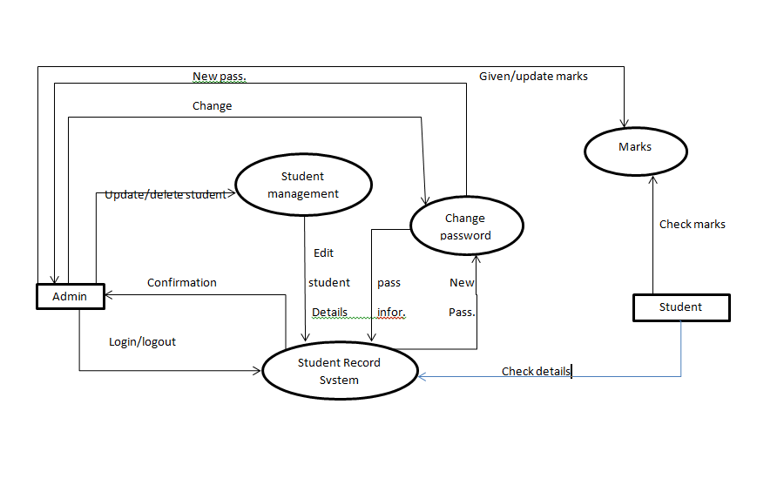

Fig 3.1 DFD

* 1. **USE CASE DIAGRAM**

A use case diagram at its simplest is a representation of a user's interaction with the system that shows the relationship between the user and the different [use cases](https://en.wikipedia.org/wiki/Use_case) in which the user is involved. A use case diagram can identify the different types of users of a system and the different use cases and will often be accompanied by other types of diagrams as well. The use cases are represented by either circles or ellipses.

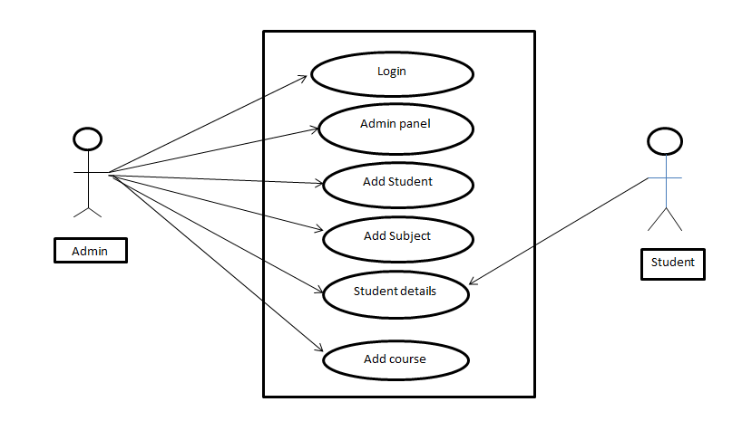

### E-R Diagram:

An entity relationship model, also called entity-relationship (ER) diagram, is a graphical representation of entities and their relationships to each other, typically used in computing in regards to the organization of data within database or information systems. An entity is a piece of data about which data is stored.

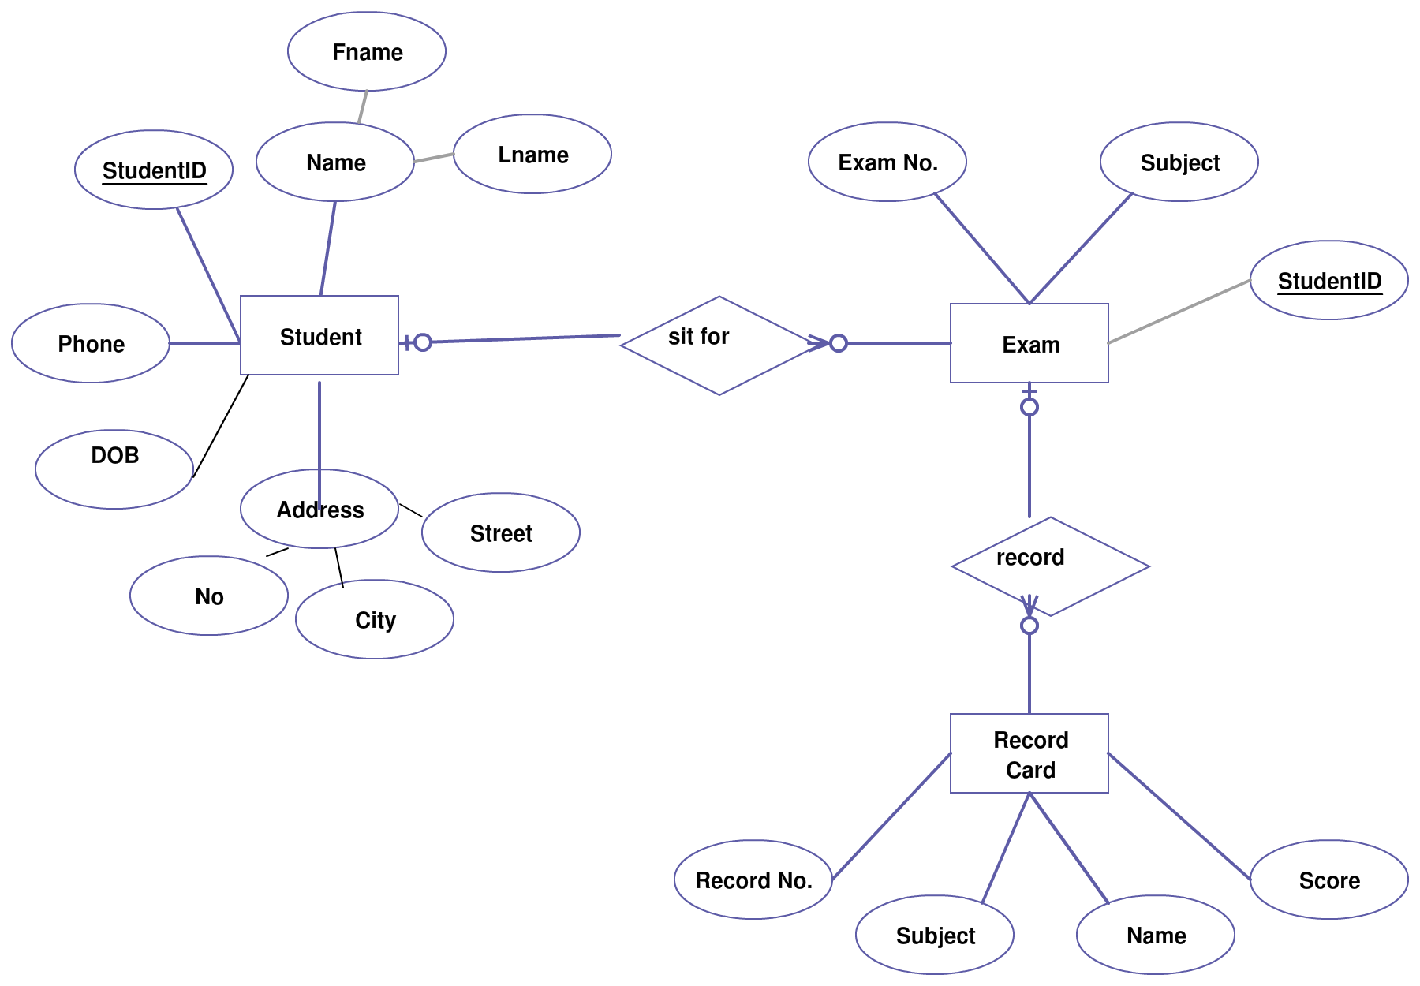

Fig 3.3 E-R Diagram

## CHAPTER 4: IMPLEMENTATION

### 4.1 Screenshots

1. **Login Page:** This page is showing at first when we run system.

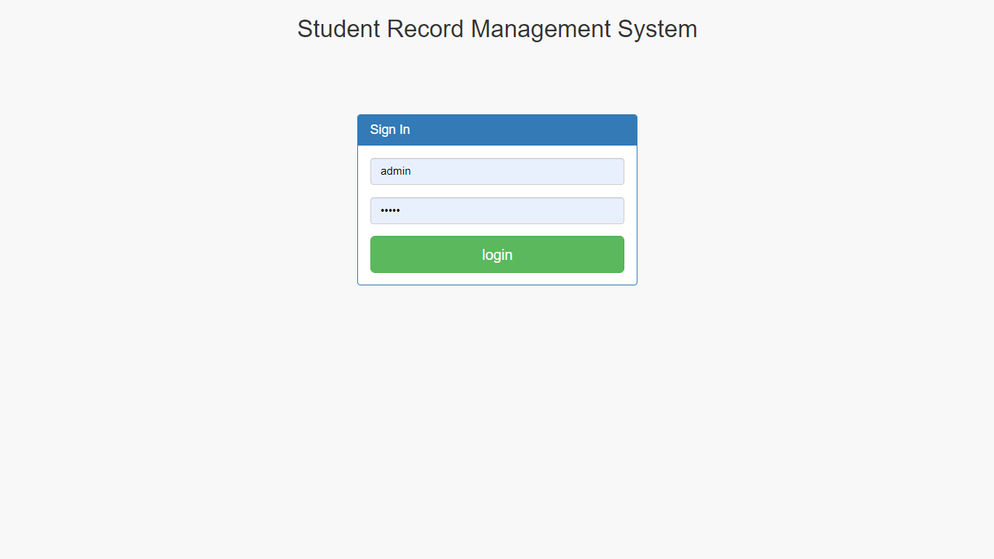

Fig 4.1: Login Panel

1. **Home Page:** When admin successfully login then admin page will open. There are various functionality for admin like Add Student, Edit Student, Add Course, Edit Course,Add Subject, Edit Subject, Logout .

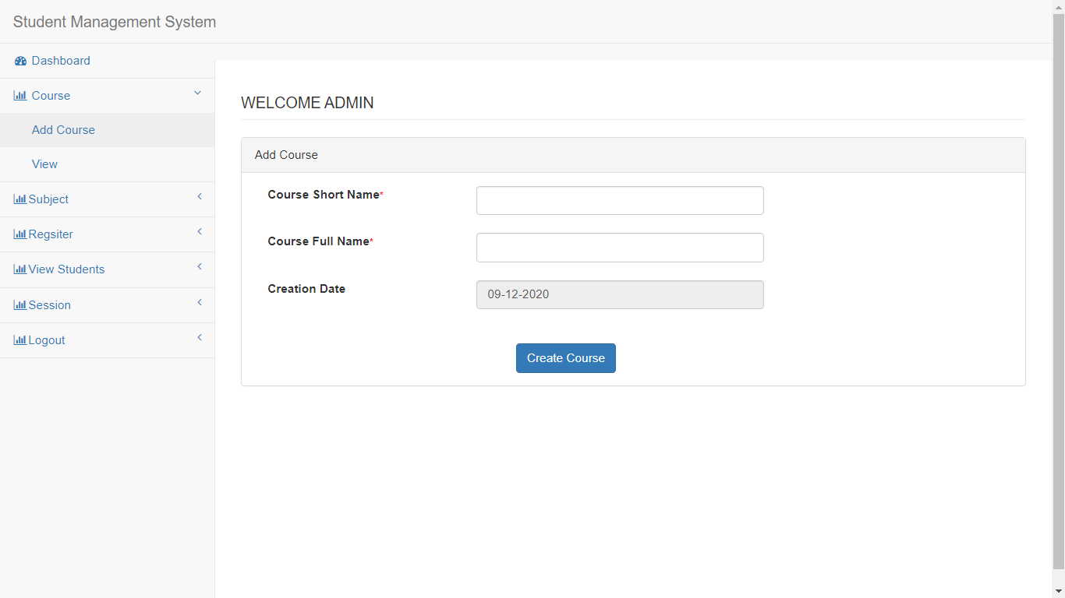

Fig 4.2: Home Page

1. **Add Student:** When admin want to register any Student then he can easily add by giving all required information like Name, Email, Password and Phone No Address .

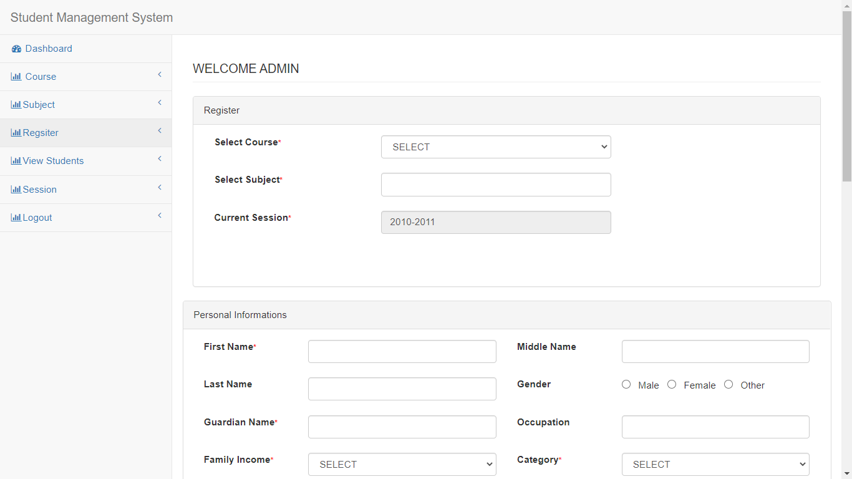

Fig 4.4: Add Student

1. **View Student Details:** When student get registered successfully then admin can see the student details.

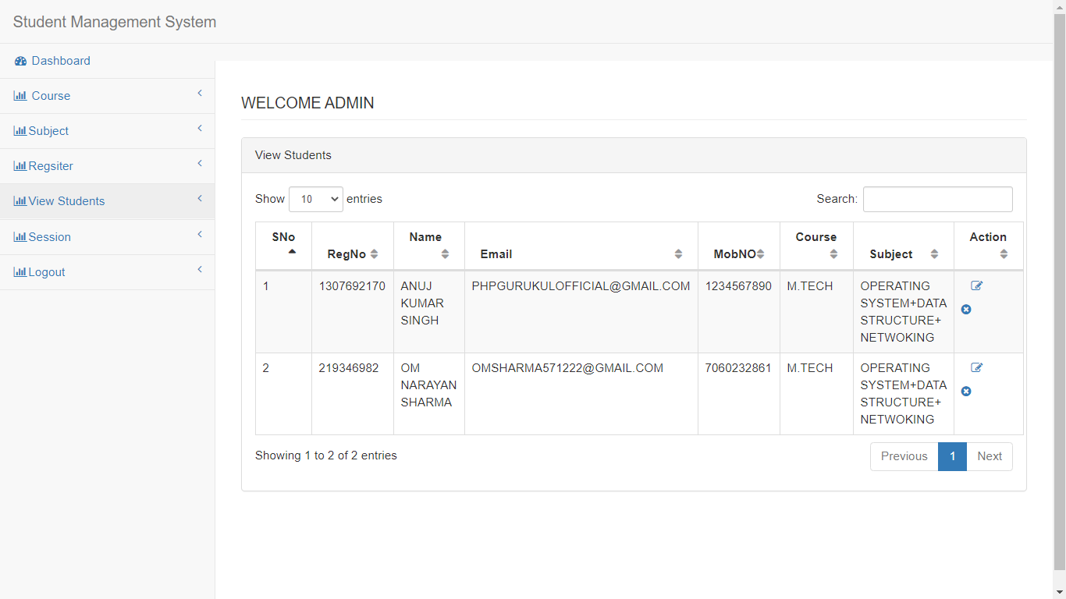

Fig 4.5: View Student Details

1. **Update Student:** When student details need update then admin can update Student details successfully.

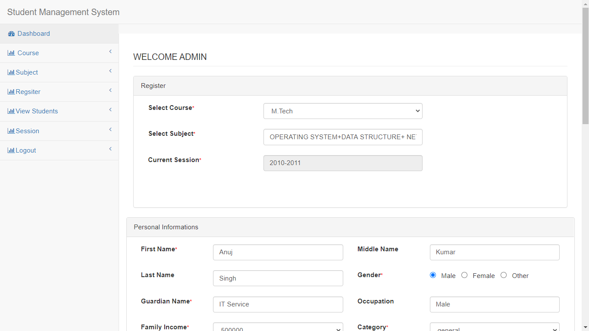

Fig: 4.6 Update Student details

1. **Add Course:** If admin want to add any course in their school/college he can easily add any course by giving all details of course.



Fig: 4.8: Add Course

1. **View Course Details:** If course added successfully in the school/college then Admin can see total course details.

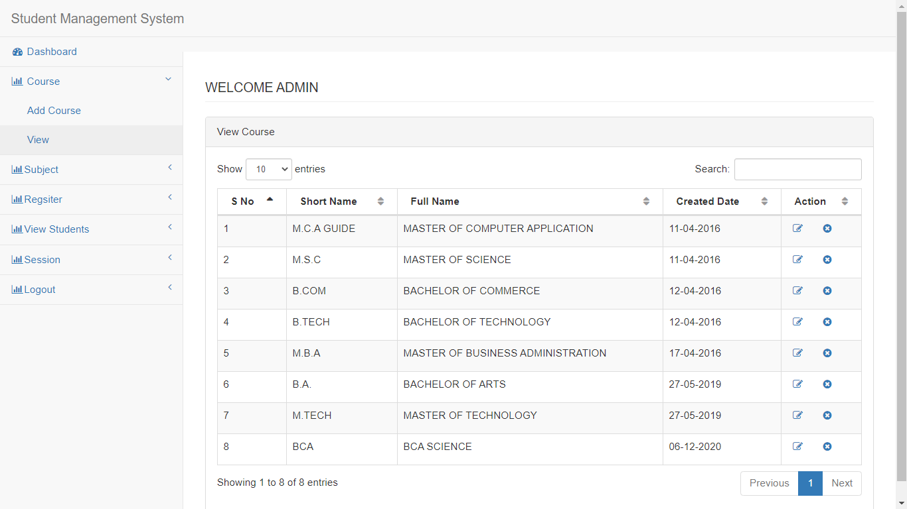

Fig 4.9: View Course Details

1. **Edit Course Details:** This page open when admin want to edit the details of course in their school/college.

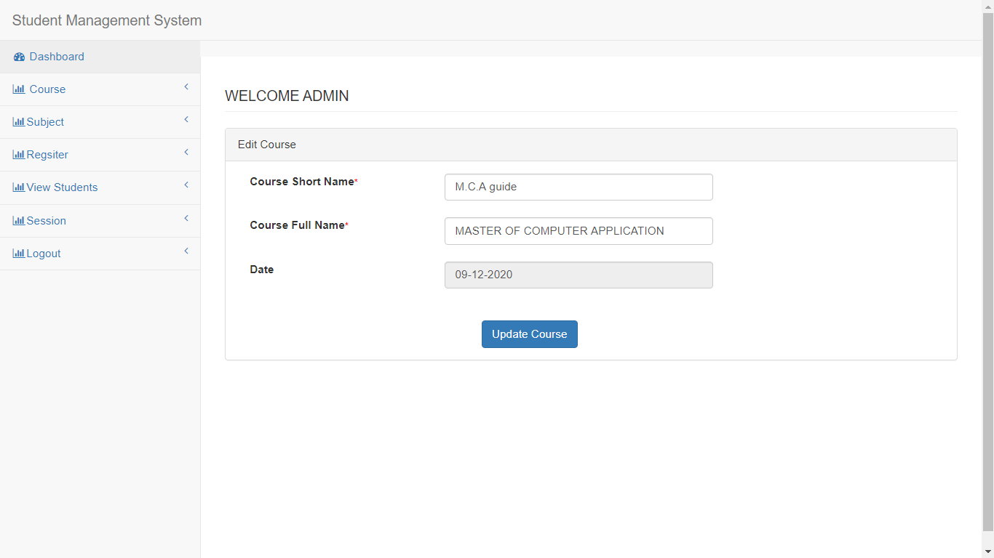

Fig 4.10: Edit Course

DEPT. OF CEA, GLAU, MATHURA 12

8

1. **Add Subject:** This page add subject successfully.

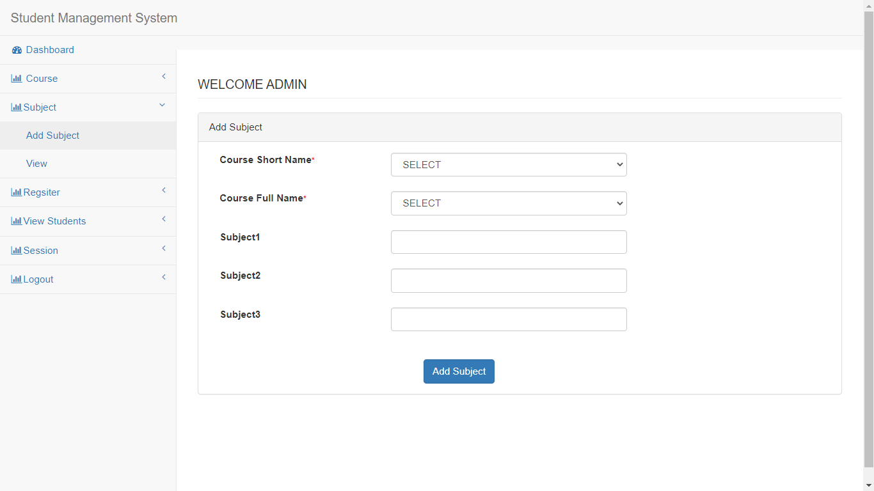

Fig 4.11: Add Subject

DEPT. OF CEA, GLAU, MATHURA 13

8

1. **Edit Subject Details:** This page open when admin want to edit subject details.

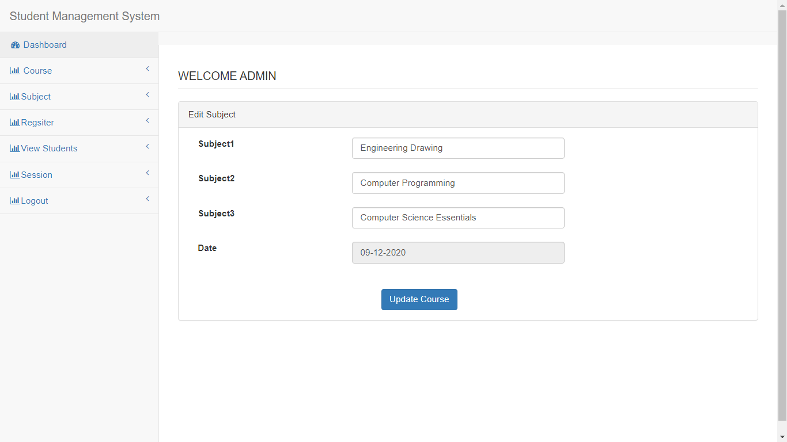

Fig 4.13 Edit Subject details

1. **View Subject Details:** This page open when admin want to view subject details.

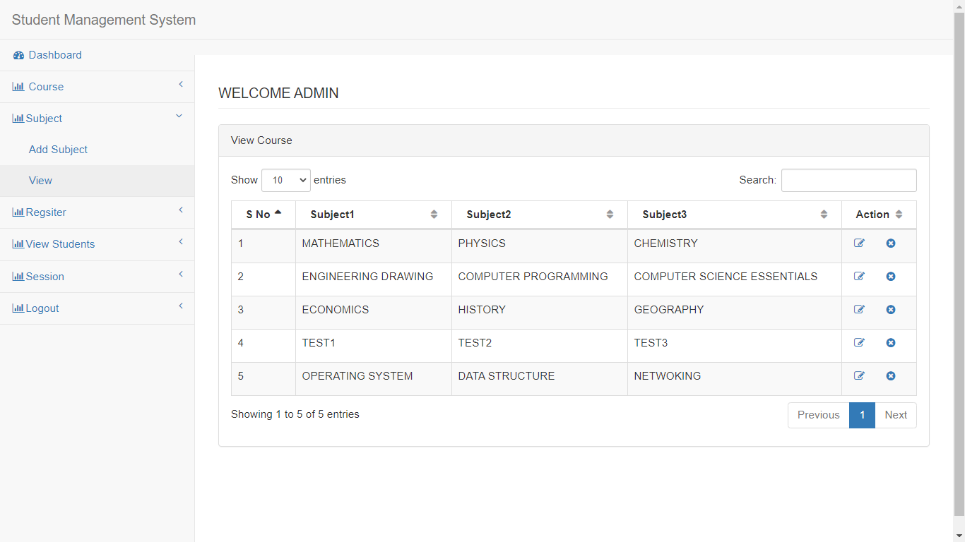

Fig 4.12: View Subject details

## CHAPTER – 5 : SOFTWARE TESTING

#### INTRODUCTION

The success of the testing process is determining the errors which mostly depend upon the test case criteria, for testing any software we need to have a description of the expected behavior of the system and method of determining whether the observed behavior confirmed to the expected behavior.

#### Level of Testing:

Since the errors in the software can be injured at any stage. So, we have to carry out the testing process at different level during the development. The basic levels of testing are Unit Testing, Integration Testing, System Testing and Acceptance Testing. The Unit Testing is carried out on coding. Here different modules are tested against the specifications produces during design for the modules. In case of Integration Testing different tested modules are combined into sub systems and tested. In case of the system testing the full software is tested and in the next level of testing the system is tested with user requirement document prepared during SRS. There are two basic approaches for testing. They are

#### Functional Testing:

In functional testing test cases are decided solely on the basis of requirements of the program or the module and the internals of the program or modules are not considered for selection of test cases. This is also called Black Box Testing.

#### Structural Testing:

In Structural Testing test cases are generated on actual code of the program or module to be tested. This is called White Testing.

#### TESTING PROCESS

A number of activities must be performed for testing software. Testing starts with test plan. Test plan identifies all testing related activities that need to be performed along with the schedule and guide lines for testing. The plan also specifies the levels of testing that need to be done, by identifying the different testing units. For each unit specified in the plan first the test cases and reports are produced. These reports are analyzed.

#### Test plan:

Test plan is a general document for entire project, which defines the scope, approach to be taken and the personal responsible for different activities of testing. The inputs for forming test plans are:

Project plan Requirements documents System design

#### Test Case Specification:

Although there is one test plan for entire project test cases have to be specified separately for each test case. Test case specification gives for each item to be tested. All test cases and outputs expected for those test cases.

#### Test Case Execution and Analysis:

The steps to be performed for executing the test cases are specified in separate document called test procedure specification. This document specify any specify requirements that exist for setting the test environment and describes the methods and formats for reporting the results of testing.

#### Unit Testing:

Unit testing mainly focused first in the smallest and low level modules, proceeding one at a time. Bottom-up testing was performed on each module. As developing a driver program, that tests modules by developed or used. But for the purpose of testing, modules themselves were used as stubs, to print verification of the actions performed. After the lower level modules were tested, the modules that in the next higher level those make use of the lower modules were tested.

Each module was tested against required functionally and test cases were developed to test the boundary values.

#### Integration Testing:

Integration testing is a systematic technique for constructing the program structure, while at the same time conducting tests to uncover errors associated with interfacing. As the system consists of the number of modules the interfaces to be tested were between the edges of the two modules. The software tested under this was incremental bottom-up approach.

Bottom-up approach integration strategy was implemented with the following steps. Low level modules were combined into clusters that perform specific software sub fractions.

#### System Testing:

System testing is a series of different tests whose primary purpose is to fully exercise the computer based system. It also tests to find discrepancies between the system and its original objective, current specifications

#### System Test Cases and System Test Report:

The System Test Cases mentioned below are expected to work and give the expected behavior if the explorer is configured to run jar files.

# Test Cases:

#### Test Case #1 : Login Form

|  |  |  |  |
| --- | --- | --- | --- |
| **S.No.** | **Test Case Description** | **Expected Result** | **Status** |
| **1** | Login page | Admin login successfully | Pass |
| **2** | Invalid e-mail or  password | Login failed | Pass |
| **3** | Starting the software | Start Panel occurs | Pass |

**Test Case #2 : Admin Panel**

|  |  |  |  |
| --- | --- | --- | --- |
| **S.No.** | **Test Case Description** | **Expected Result** | **Status** |
| 1 | Add Student | Student is  registered successfully. | Pass |
| 2 | Delete Student | Student is deleted successfully . | Pass |
| 3 | Update Student | Student details is updated. | Pass |
| 4 | Add Course | Course is  Added successfully | Pass |

DEPT. OF CEA, GLAU, MATHURA 19

21

|  |  |  |  |
| --- | --- | --- | --- |
| 5 | Delete Course | Course is deleted successfully . | Pass |
| 6 | Update Course | Course details is updated. | Pass |
| 7 | Add Subject | Subject is registered successfully. | Pass |
| 8 | Delete Subject | Subject is deleted successfully . | Pass |
| 9 | Update Subject | Subjcet details is updated. | Pass |

DEPT. OF CEA, GLAU, MATHURA 20

21

**CHAPTER 6: CONCLUSION**

Software Testing

* Student Management System can be used by educational institutions to maintain their student records easily.
* This system helps in maintaining the information of Student/ Course/Subject record of the organization.
* It can be easily accessed by the admin and kept safe for a long period of time without any changes.
* All these problems are solved by this project.

#### Future Prospects

#### Add Student Attendance in future

* In future we give update that adding particular marks of term exam
* Add different types of payment mode.

## BIBLIOGRAPHY

The following references were used while doing this project:

1. [https://courses.smartprogramming.in](https://courses.smartprogramming.in/)
2. <https://www.w3schools.com/java/>
3. <https://www.tutorialspoint.com/java/index.htm>
4. <https://www.guru99.com/java-tutorial.html>